Target Audience: Aspiring Spark developers from Data warehousing background

Mohamed Suhaib (Cognizant)

Cognizant Technology Solutions  Mohamed.Suhaib@cognizant.com

ETL with spark and scala

Contents

Using Timestamp Datatype: 2

Implementing SCD2 4

Pivoting 12

Retrieving top 2 values from each field 13

Window Function 14

Explode function to split a String Column 16

# Using Timestamp Datatype:

scala> :paste

// Entering paste mode (ctrl-D to finish)

import org.apache.spark.sql.functions.{current_date, current_timestamp}

valdateDF = sqlContext.range(10)

.withColumn("today", current_date())

.withColumn("now", current_timestamp())

dateDF.show

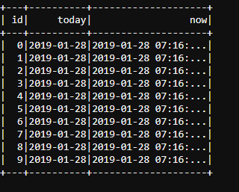

dateDF.withColumn("Year",year(dateDF("today"))).show

dateDF.withColumn("Week",weekofyear(dateDF("today"))).show

dateDF.withColumn("Month",month(dateDF("today"))).show

dateDF.withColumn("Month",dayofmonth(dateDF("today"))).show

dateDF.withColumn("cur_minute",minute(col("now"))).show

dateDF.withColumn("cur_second",second(col("now"))).show

dateDF.withColumn("new_added_months_date", expr("add_months(today, 7)")).show

Useful Date functions with Dataframes:

|  |  |
| --- | --- |
| **Function** | **Description** |
| date_sub | To subtract specific number of days from a give date |
| date_add | To add specific number of days from a give date |
| datediff | To subtract two dates |
| months_between | To find the number of months between two dates |
| to_date | To conver a string literal to a date |
| year | To extract year from date |
| weekofyear | To extract week of year |
| month | To extract month from date |
| dayofmonth | To extract day of month |
| minute | To extract minute from timestamp |
| second | To extract second from timestamp |
| add_months | To add months to date |

To change the date format:

valdateFormat = "yyyy-dd-MM"

sqlContext.range(1).select(

to_date(from_unixtime(unix_timestamp(lit("20171211"), "yyyyMMdd"), dateFormat)).alias("date")).show

# Implementing SCD2

Initial load:

// brief description about steps followed to build SCD2.

// 1. yelp_data_actHist = Active records from History file which are not found in current file.

// 2. yelp_data_intersect = Active records from History file for which there are no updates in current file (same record is available).

// 3. yelp_data_expired = Inactive records from History file.

// 4. yelp_data_upnew_date = Set of Updated and new records from current file.

// 5. yelp_data_upexp_date = End date updated records from history as the updates found for them in current file.

InputFile:

hadoop fs -cat yelp_user_20190129.csv

user_id,name,yelping_since,useful,elite,average_stars

zzNKg1,Jenna,2011-12-20,0,None,5.0

zzNKg2,Jenna,2011-12-20,2500,2015 2016 2017,4.5

zzNKg3,Jenna,2011-12-20,3000,2015 2016 2018,3.5

zzNKg4,Jenna,2011-12-20,3400,2015 2017 2018,4.0

import org.apache.hadoop.fs.{FileSystem, Path}

import org.apache.hadoop.fs._

import org.apache.spark.sql._

import org.apache.spark.sql.functions._

import scala.io.Source

import java.text.SimpleDateFormat

valproc_dt = "20190129"

valinputFormat = new SimpleDateFormat("yyyyMMdd")

valreqFormat = new SimpleDateFormat("yyyy-MM-dd")

// Convert the effective and expiry date in yyyy-MM-dd format

valeff_dt = reqFormat.format(inputFormat.parse(proc_dt))

valexp_dt = reqFormat.format(reqFormat.parse("9999-12-31"))

valhistPath = new Path("/user/respond474/yelp_hist/")

valhistTabPath= "/user/respond474/yelp_hist/"

valinput_file = s"/user/respond474/yelp_user_20190129.csv"

val fs = FileSystem.get(sc.hadoopConfiguration)

sqlContext.setConf("spark.sql.shuffle.partitions", "10")

import sqlContext.implicits._

// Check if the HIST table directory present for first run, else create directory

if (!fs.exists(histPath)) {

println("History table directory does not exist, creating directory")

fs.mkdirs(histPath)

} else {

println("History table directory exist")

}

valyelp_data = sqlContext.read.format("com.databricks.spark.csv").

option("header", "true").

option("inferSchema", "true").

option("quote", "\"").

load(input_file)

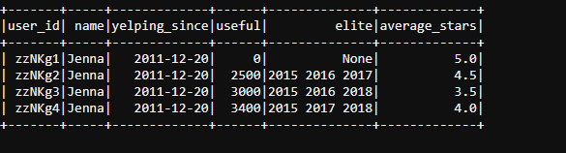

valyelp_data_hist = yelp_data.withColumn("eff_dt",to_date(from_unixtime(unix_timestamp(lit(eff_dt),"yyyy-MM-dd"), "yyyy-MM-dd"))).withColumn("exp_dt",to_date(from_unixtime(unix_timestamp(lit(exp_dt),"yyyy-MM-dd"), "yyyy-MM-dd")))

import org.apache.spark.sql.SaveMode

yelp_data_hist.coalesce(2).write.mode(SaveMode.Overwrite).format("orc").saveAsTable("respond474.yelp_hist")

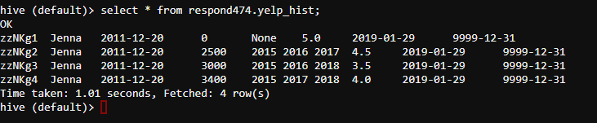

Incremental load:

hadoop fs -cat yelp_user_20190130.csv

user_id,name,yelping_since,useful,elite,average_stars

zzNKg1,Jenna,2011-12-20,3400,2015 2018 2018,8.0

BBBBB1,Jenna,2011-12-20,3400,2015 2018 2018,12.0

valstgPath = new Path("/user/respond474/yelp_hist_stg/")

valhistPath = new Path("/apps/hive/warehouse/respond474.db/yelp_hist")

valhistTabPath = "/apps/hive/warehouse/respond474.db/yelp_hist"

valstgTabPath = "/user/respond474/yelp_hist_stg/"

valinput_file = s"/user/respond474/yelp_user_20190130.csv"

valyelp_data_stg = sqlContext.read.format("com.databricks.spark.csv").

option("header", "true").

option("inferSchema", "true").

option("quote", "\"").

load(input_file)

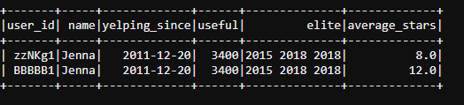

valyelp_data_hist = sqlContext.read.orc(histTabPath)

yelp_data_hist.cache

valyelp_data_expired = yelp_data_hist.as("hist").filter($"exp_dt" !== "9999-12-31").select($"hist.*")

valyelp_data_intersect = yelp_data_hist.as("hist").filter($"exp_dt"==="9999-12-31").

join(yelp_data_stg.as("stg"), Seq("user_id"), "inner").

where($"hist.exp_dt" === "9999-12-31"

&& $"hist.useful" === $"stg.useful"

&& $"hist.average_stars" === $"stg.average_stars"

&& $"hist.yelping_since" === $"stg.yelping_since"

&& $"hist.name" === $"stg.name"

&& $"hist.elite" === $"stg.elite"). select($"hist.*")

//New or updated records

valyelp_data_upnew = yelp_data_stg.as("stg").

join(yelp_data_hist.as("hist").filter($"exp_dt"==="9999-12-31"), $"hist.user_id" === $"stg.user_id", "left").

where(

($"hist.user_id".isNull) ||

($"hist.user_id" === $"stg.user_id" &&

(($"hist.useful" !== $"stg.useful" ) ||

($"hist.yelping_since" !== $"stg.yelping_since" ) ||

($"hist.name" !== $"stg.name" ) ||

($"hist.average_stars" !== $"stg.average_stars")

))).select($"stg.*")

valyelp_data_upnew.show()

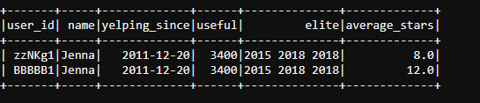

valyelp_data_upnew_date = yelp_data_upnew.withColumn("eff_dt",to_date(from_unixtime(unix_timestamp(lit(eff_dt), "yyyy-MM-dd"), "yyyy-MM-dd"))).

withColumn("exp_dt",to_date(from_unixtime(unix_timestamp(lit("9999-12-31"),"yyyy-MM-dd"), "yyyy-MM-dd")))

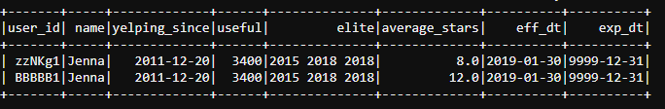

// Get old updated user_id from the HIST table and set expiry date i.e. (2099-12-31)

valyelp_data_upexp = yelp_data_hist.as("hist").filter($"exp_dt"==="9999-12-31").

join(yelp_data_stg.as("stg"), Seq("user_id"), "inner").

where(

($"hist.useful" !== $"stg.useful" ) ||

($"hist.yelping_since" !== $"stg.yelping_since" ) ||

($"hist.name" !== $"stg.name" ) ||

($"hist.average_stars" !== $"stg.average_stars")

).select($"hist.*")

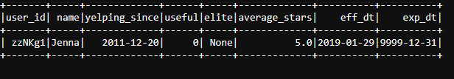

valyelp_data_upexp_date = yelp_data_upexp.withColumn("exp_dt",to_date(from_unixtime(unix_timestamp(lit(exp_dt),"yyyy-MM-dd"), "yyyy-MM-dd")))

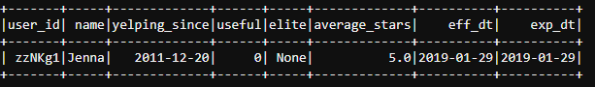

// Active user_id from the HIST table that are not in STG

valyelp_data_actHist = yelp_data_hist.as("hist").filter($"exp_dt"==="9999-12-31").

join(yelp_data_stg.as("stg"), $"hist.user_id" === $"stg.user_id", "left").

where( $"stg.user_id".isNull).select($"hist.*")

// Merge data from all the above dataframes to create historical table data

valdfUnion = Seq(yelp_data_actHist,yelp_data_intersect,yelp_data_expired,yelp_data_upnew_date,yelp_data_upexp_date)

valyelp_data_all = dfUnion.reduce(_.unionAll(_))

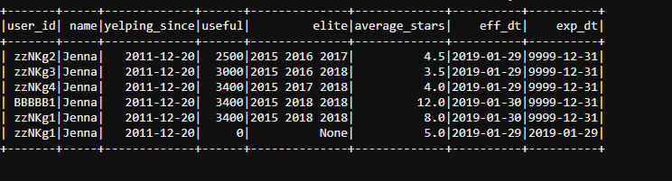

yelp_data_all.write.mode(SaveMode.Overwrite).format("orc").save(stgTabPath)

yelp_data_all.cache

if (fs.exists(histPath)) {

println("History table directory exist, deleting the old table data")

fs.delete(histPath)

} else {

println("History table directory does not exist")

}

if (fs.exists(stgPath)) {

println("Staging directory is loaded with updated data, ")

fs.rename(stgPath,histPath)

} else {

println("Staging directorydoes not exist")

}

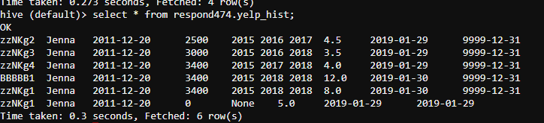

# Pivoting

Input file [pivot_input.csv]

id,tag,value

1,US,50

1,UK,100

1,Can,125

2,US,75

2,UK,150

2,Can,175

valinputDF = sqlContext.read.format("com.databricks.spark.csv").

option("header", "true").

option("inferSchema", "true").

load("pivot_input.csv")

inputDF.groupBy("id").pivot("tag").agg(sum("value")).show

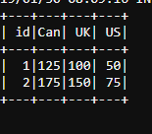

# Retrieving top 2 values from each field

input_file(mixName.txt):

mixname,soda,formula1,formula2,formula3

m1,10,1.5,2.5,3.4

m2,20,1.3,2.3,3.1

m3,15,1.8,2.9,3.0

m4,12,1.1,2.1,3.9

Steps to transform input as below:

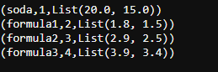

valdf = sc.textFile("/user/respond474/mixName.txt").filter(x=> (x.split(",")(1) != "soda")).map(x => {val v = x.split(","); (v(0), v(1).toDouble, v(2).toDouble, v(3).toDouble, v(4).toDouble)}).toDF("mixname","soda","formula1","formula2","formula3")

valrowLength = df.schema.length

valrankRDD = df.flatMap( row => Range(1, rowLength).map(i => (i, row.getDouble(i))))

valrankSorted = rankRDD.groupByKey.map(x => (x._1, x._2.toArray.sortWith(_>_))).sortByKey(true)

valfinal_res = rankSorted.map(x => (x._1, x._2.zipWithIndex)).map(row => (row._1, Range(0, 2).map(i => row._2(i)).map(x=> x._1).toList))

val header = sc.textFile("/user/respond474/mixName.txt").first.split(",")

val final_res_1 = final_res.map(row => (header(row._1), row._1, row._2))

# Window Function

case class Salary(depName: String, empNo: Long, salary: Long)

valempsalary = Seq(

Salary("sales", 1, 5000),

Salary("personnel", 2, 3900),

Salary("sales", 3, 4800),

Salary("sales", 4, 4800),

Salary("personnel", 5, 3500),

Salary("develop", 7, 4200),

Salary("develop", 8, 6000),

Salary("develop", 9, 4500),

Salary("develop", 10, 5200),

Salary("develop", 11, 5200)).toDF

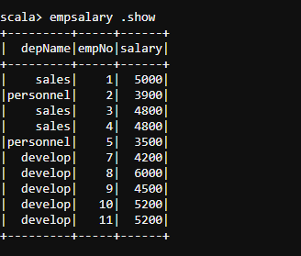

import org.apache.spark.sql.expressions.Window

valbyDepName = Window.partitionBy('depName)

empsalary.withColumn("avg", avg('salary) over byDepName).show

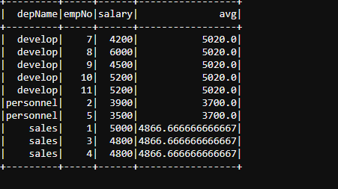

/////////////////////////////////////////////////////////////////////

valbyDepnameSalaryDesc = Window.partitionBy('depname).orderBy('salary desc)

valrankByDepname = rank().over(byDepnameSalaryDesc)

empsalary.select('*, rankByDepname as 'rank).show

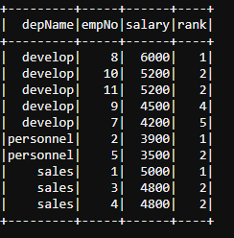

//////////////////////////////////////////////////////////////////////

valpartitionWindow = Window.partitionBy($"depname").orderBy($"salary".desc).rowsBetween(1,1)

The window frame is defined as starting from 1 (one row after the current row) and ending at 1 (one row after the current row)

Preceding row can be indicated as -1 (one row before the current row)

valnext_val = max($"salary").over(partitionWindow)

empsalary.select($"*", next_val as 'nextSalary).show

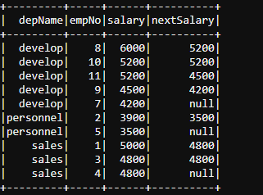

# Explode function to split a String Column

Input file(child_parent.txt):

P1|C1,C2,C3

P2|A1,A2,A3

P3|B1,B2,B3

valdf = sc.textFile("/user/respond474/child_parent.txt").map(x => (x.split('|')(0),x.split('|')(1))).toDF("Parent", "Child")

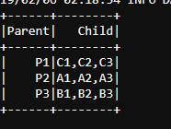

df.withColumn("splitted", split(col("Child"), ",")).withColumn("exploded", explode(col("splitted"))).drop(col("splitted")).show

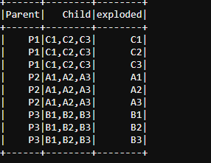

It is also possible to add depth using spark-sql.

val df1 = df.withColumn("splitted", split(col("Child"), ","))

df1.registerTempTable("df_tab")

sqlContext.sql("""

select

Parent, Child, exploded.dIndex + 1 as depth, exploded.splitted

from

df_tab

lateral view posexplode(df_tab.splitted) exploded as dIndex, splitted

""").show

